Zen Project 3

Git hub repo url: https://github.com/ayesha803/zen-project-3.git

Docker images:

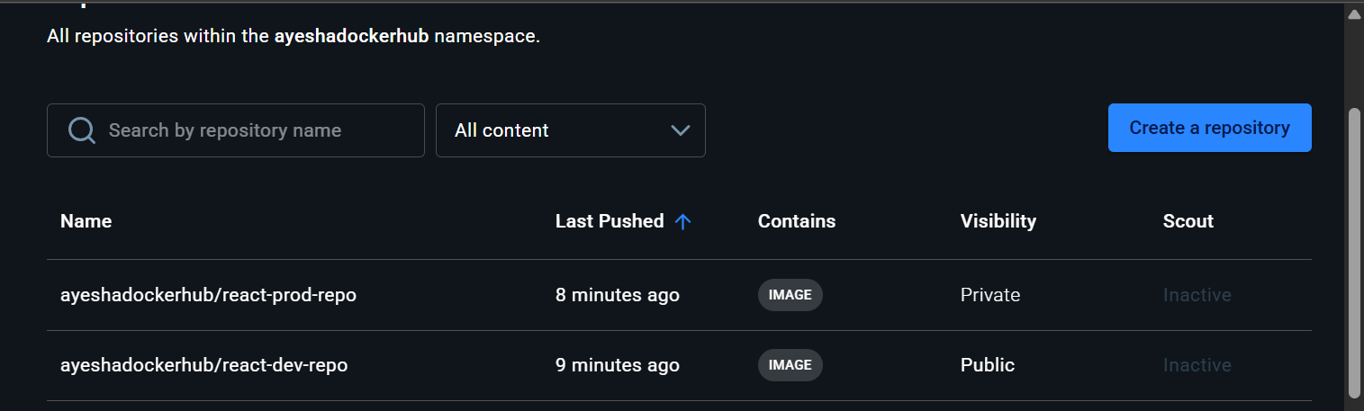

ayeshadockerhub/react-dev-repo
ayeshadockerhub/react-prod-repo

Deployed site URL: http://100.31.149.105/

Jenkins:

Login page:

Configuration:

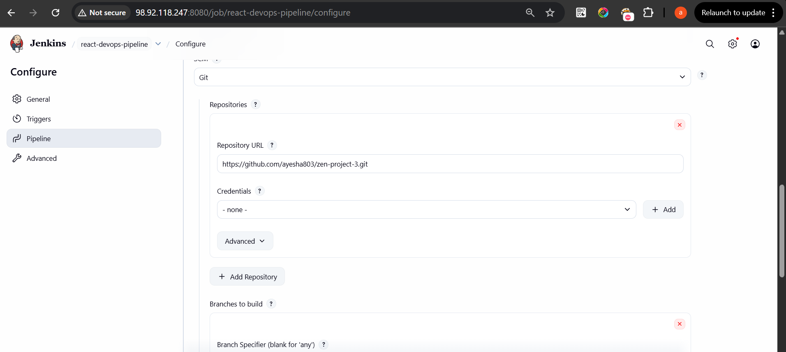

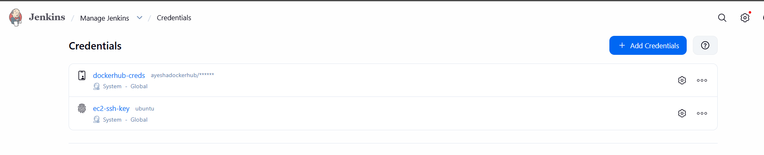

Execute step commands:

Jenkinsfile:

pipeline {
agent any

environment {
DEV_REPO = "ayeshadockerhub/react-dev-repo"
PROD_REPO = "ayeshadockerhub/react-prod-repo"
APP_SERVER = "100.31.149.105"
}

stages {

stage('Debug') {
steps {
echo "The current branch is: ${env.GIT_BRANCH}"
}
}

stage('Build Image') {
steps {
sh 'chmod +x build.sh'
sh './build.sh'
}
}

stage('Docker Login') {
steps {
withCredentials([usernamePassword(
credentialsId: 'dockerhub-creds',
usernameVariable: 'DOCKER_USER',
passwordVariable: 'DOCKER_PASS'
)]) {
sh 'echo $DOCKER_PASS | docker login -u $DOCKER_USER --password-stdin'
}
}
}

stage('Push to Dev Repo') {
when {
expression { env.GIT_BRANCH == 'origin/dev' }
}
steps {
sh '''
docker tag app-image:latest $DEV_REPO:latest
docker push $DEV_REPO:latest
'''
}
}

stage('Push to Prod Repo') {
when {
expression { env.GIT_BRANCH == 'origin/main' }
}
steps {
sh '''
docker tag app-image:latest $PROD_REPO:latest
docker push $PROD_REPO:latest
'''
}
}

stage('Deploy to App Server') {
when {
expression { env.GIT_BRANCH == 'origin/main' }
}
steps {

sshagent(['ec2-ssh-key']) {
sh '''
ssh -o StrictHostKeyChecking=no ubuntu@$APP_SERVER '
git clone https://github.com/ayesha803/zen-project-3.git
cd /home/ubuntu/zen-project-3 &&
chmod +x deploy.sh &&
./deploy.sh
'
'''
}

}
}

}
}

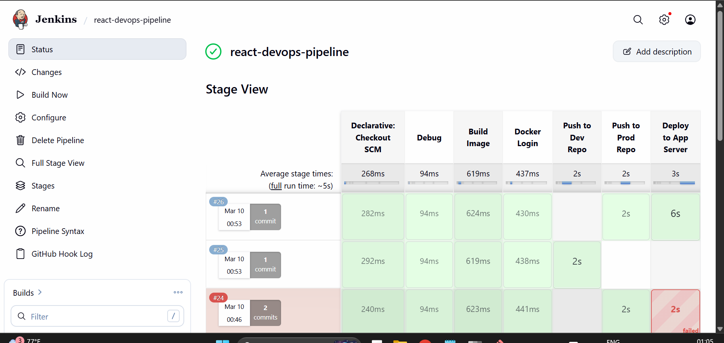

Aws EC2 Console:

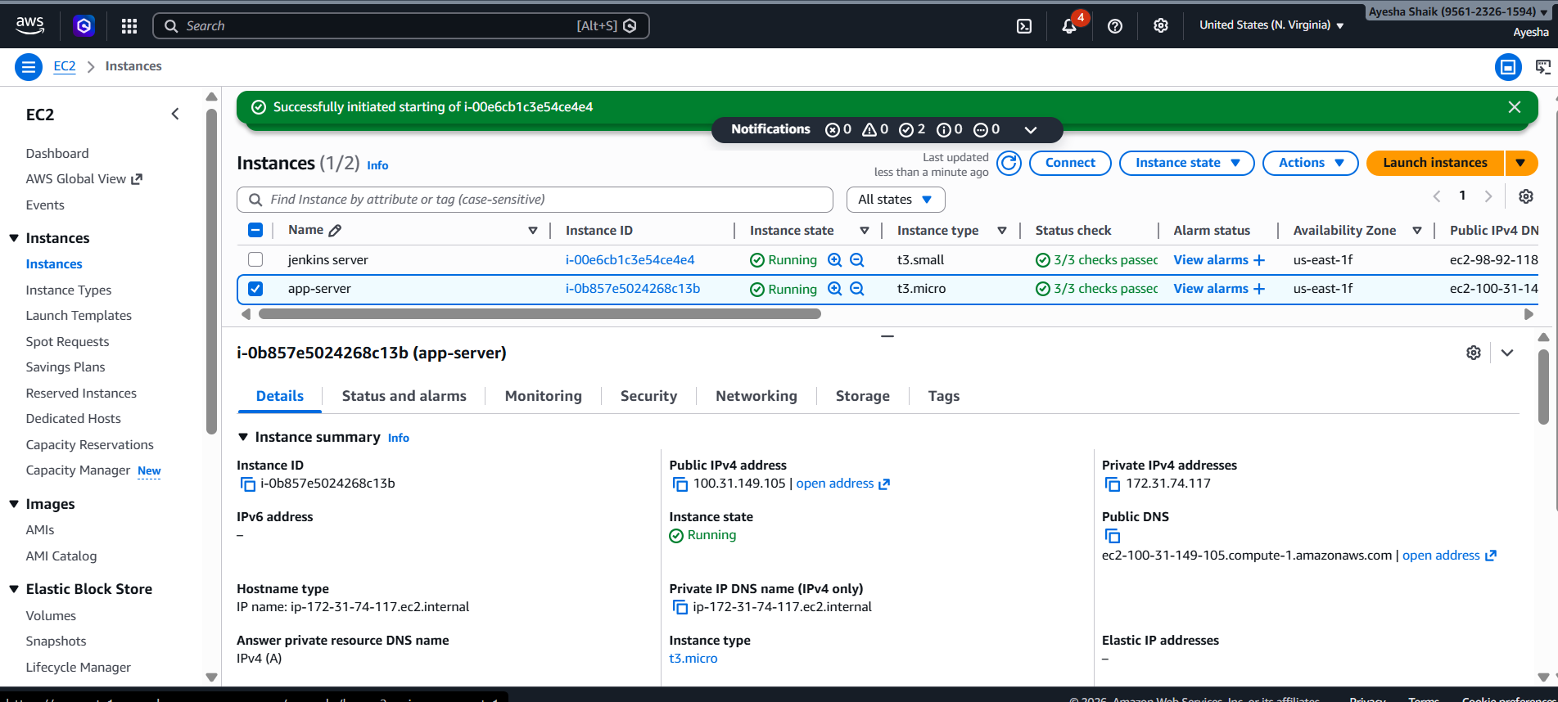

Security group:

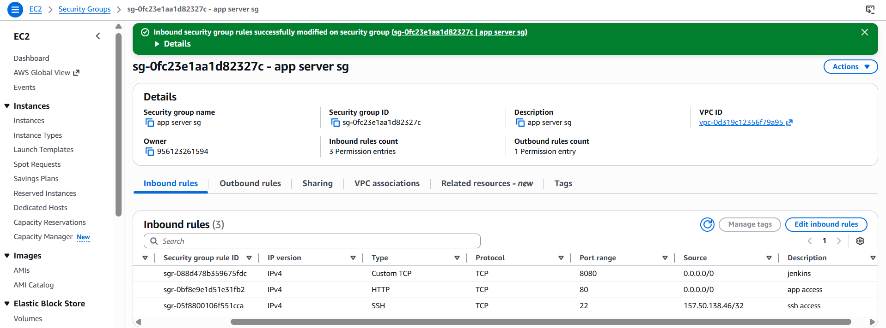

Docker hub repo:
Private repo:
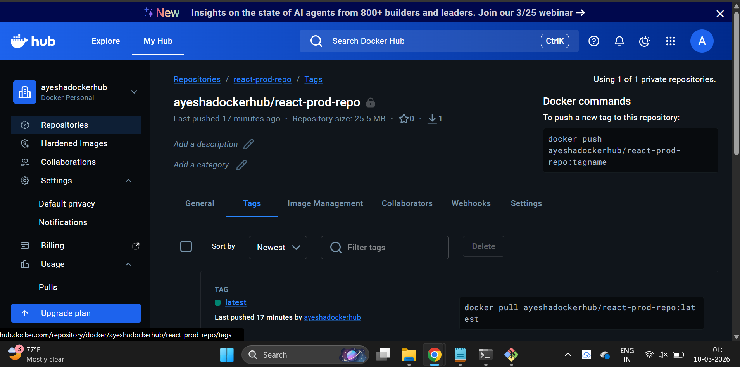

Public repo:

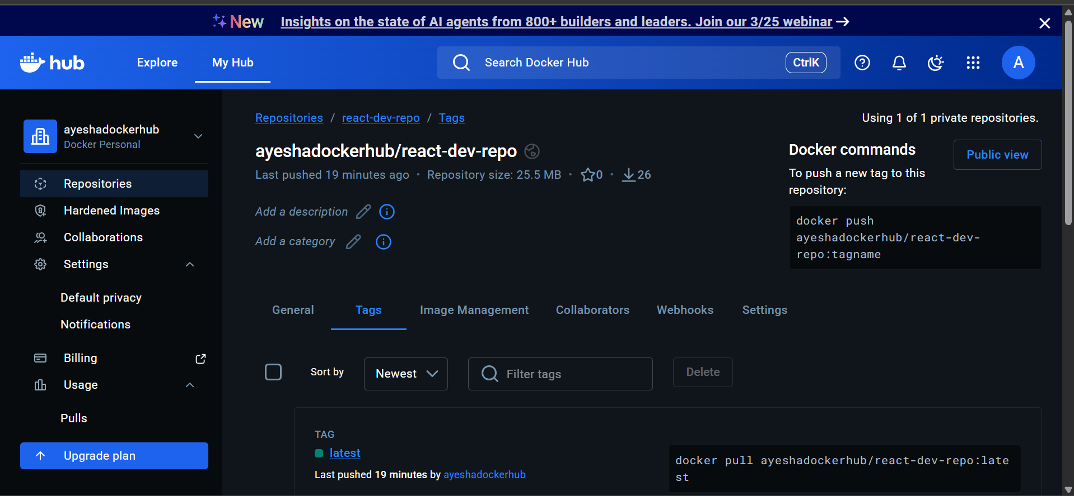

Deployed site page:

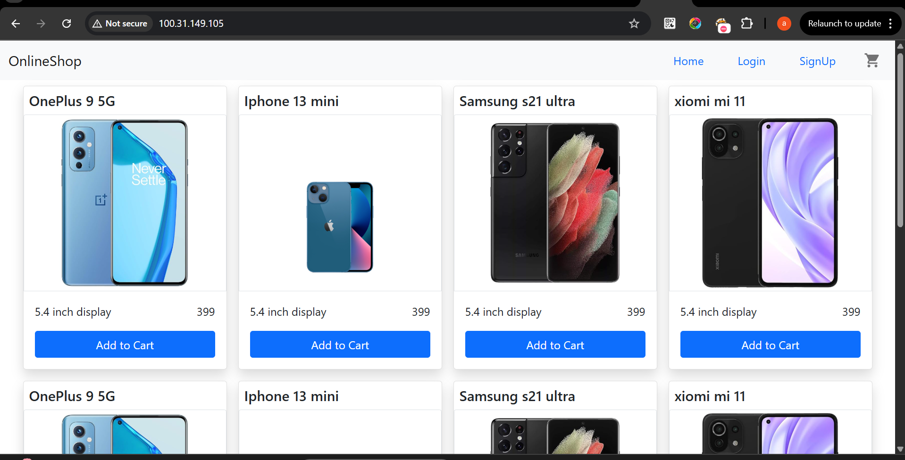

Monitoring:

